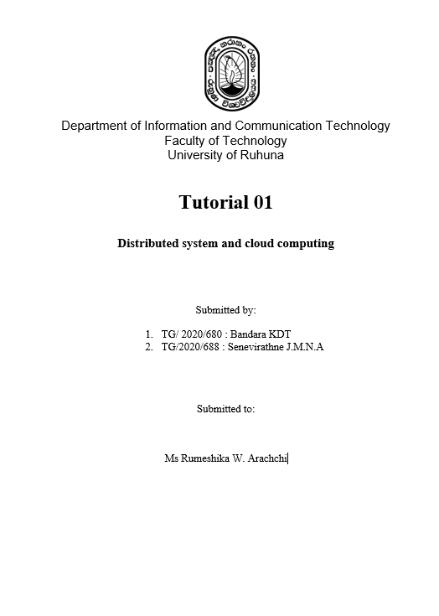

**ICT3243**

**Mobile Application Development**

**(Practical sheet 06)**

**Submitted by:**

**TG/2020/680 – KDT Bandara**

**Submitted to:**

**Ms. Malsha Prabuddhi**

**Date:**

**27th February 2025**

Stateful vs Stateless Widgets

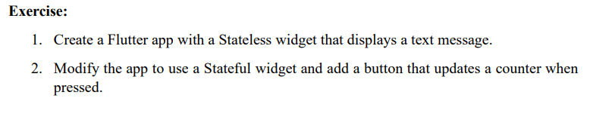

Stateless Widget

**import 'package:flutter/material.dart';**

**void main(){**

**runApp(MyApp());**

**}**

**class MyApp extends StatelessWidget{**

**@override**

**Widget build(BuildContext context){**

**return MaterialApp(**

**home: Scaffold(**

**body:Center(**

**child:Container(**

**height: 200,**

**width: 200,**

**padding: EdgeInsets.all(20),**

**decoration: BoxDecoration(**

**color: Colors.red,**

**borderRadius: BorderRadius.circular(15),**

**boxShadow: [**

**BoxShadow(color: Colors.black26, blurRadius: 5, spreadRadius: 2),**

**],**

**),**

**child: Center(**

**child: Text(**

**'Hello, Flutter!',**

**style: TextStyle(color: Colors.white, fontSize: 20),**

**),**

**),**

**),**

**),**

**),**

**);**

**}**

**}**

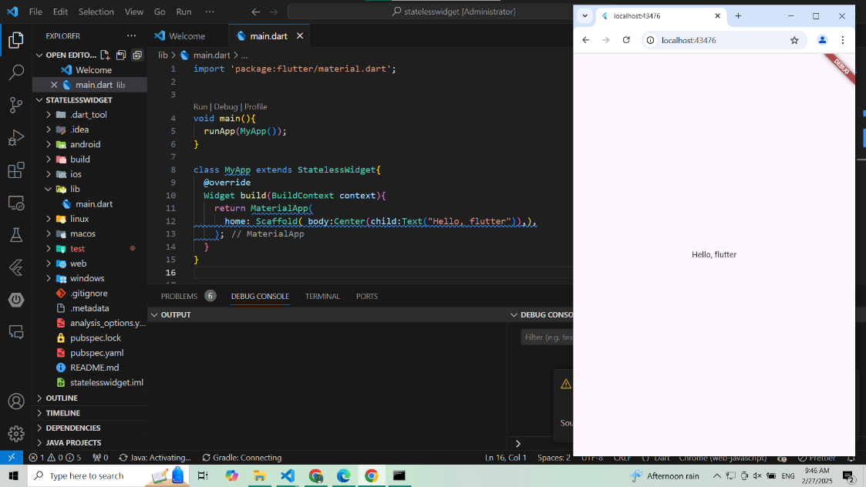

StatefulWidget

**import 'package:flutter/material.dart';**

**void main() {**

**runApp(MyApp());**

**}**

**class MyApp extends StatefulWidget {**

**@override**

**_MyAppState createState() => _MyAppState();**

**}**

**class _MyAppState extends State<MyApp> {**

**int count = 0; // Fixed variable placement**

**void incrementCount() {**

**setState(() {**

**count++;**

**});**

**}**

**@override**

**Widget build(BuildContext context) {**

**return MaterialApp(**

**home: Scaffold(**

**appBar: AppBar(title: Text('Stateful Widget Example')),**

**body: Center(**

**child: Column(**

**mainAxisAlignment: MainAxisAlignment.center,**

**children: [**

**Text("Counter: $count"),**

**ElevatedButton(**

**onPressed: incrementCount,**

**child: Text('Increment'),**

**),**

**],**

**),**

**),**

**),**

**);**

**}**

**}**

Container

**import 'package:flutter/material.dart';**

**void main() {**

**runApp(MyApp());**

**}**

**class MyApp extends StatelessWidget {**

**@override**

**Widget build(BuildContext context) {**

**return MaterialApp(**

**debugShowCheckedModeBanner: false,**

**home: Scaffold(**

**appBar: AppBar(title: Text("Hello, Flutter")),**

**body: Center(**

**child: Container(**

**width: 200,**

**height: 100,**

**margin: EdgeInsets.all(10),**

**padding: EdgeInsets.all(20),**

**decoration: BoxDecoration(**

**color: Colors.blue,**

**borderRadius: BorderRadius.circular(15),**

**boxShadow: [**

**BoxShadow(color: Colors.black26, blurRadius: 5, spreadRadius: 2),**

**],**

**),**

**child: Center(**

**child: Text(**

**'Hello, Flutter!',**

**style: TextStyle(color: Colors.white, fontSize: 20),**

**),**

**),**

**),**

**),**

**),**

**);**

**}**

**}**

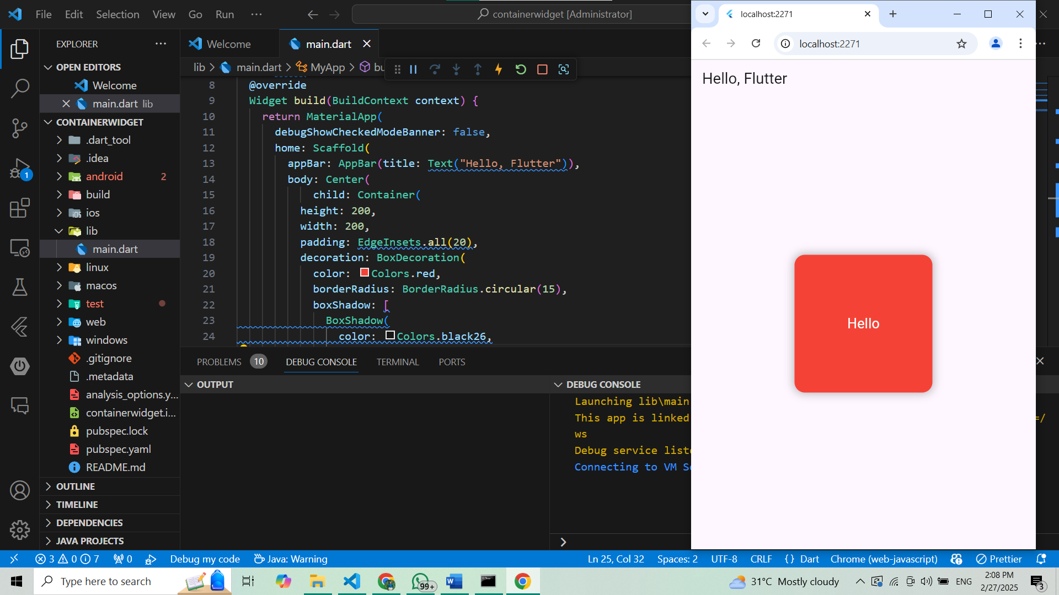

**import 'package:flutter/material.dart';**

**void main() => runApp(const MyApp());**

**class MyApp extends StatelessWidget {**

**const MyApp({Key? key}) : super(key: key);**

**@override**

**Widget build(BuildContext context) {**

**return MaterialApp(**

**home: Scaffold(**

**appBar: AppBar(**

**title: const Text("Container example"),**

**),**

**body: Container(**

**height: 200,**

**width: double.infinity,**

**color: Colors.purple,**

**alignment: Alignment.center,**

**margin: const EdgeInsets.all(20),**

**padding: const EdgeInsets.all(30),**

**transform: Matrix4.rotationZ(0.1),**

**child: const Text("Hello! i am inside a container!",**

**style: TextStyle(fontSize: 20)),**

**),**

**),**

**);**

**}**

**}**

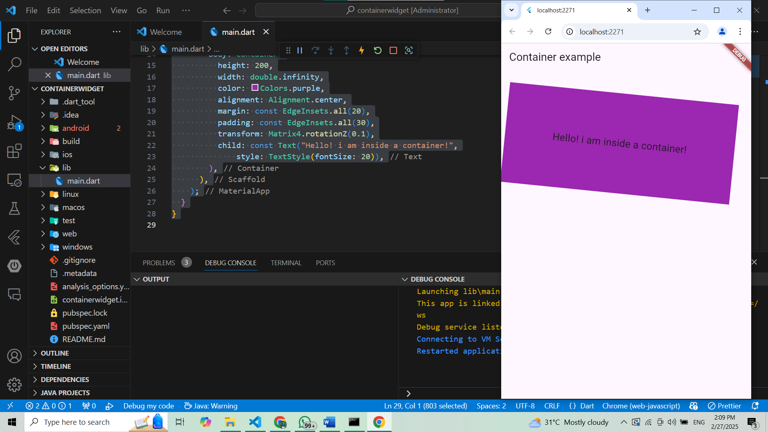

Scaffold Widget

**import 'package:flutter/material.dart';**

**void main() {**

**runApp(MyApp());**

**}**

**class MyApp extends StatefulWidget {**

**@override**

**_MyAppState createState() => _MyAppState();**

**}**

**class _MyAppState extends State<MyApp> {**

**int _selectedIndex = 0;**

**void _onItemTapped(int index) {**

**setState(() {**

**_selectedIndex = index;**

**});**

**}**

**@override**

**Widget build(BuildContext context) {**

**return MaterialApp(**

**debugShowCheckedModeBanner: false,**

**home: Scaffold(**

**appBar: AppBar(title: Text("Scaffold Example")),**

**body: Center(child: Text("Page ${_selectedIndex + 1}")), // Fixed text formatting**

**floatingActionButton: FloatingActionButton(**

**onPressed: () {**

**ScaffoldMessenger.of(context).showSnackBar(**

**SnackBar(content: Text("FAB Clicked!")),**

**);**

**},**

**child: Icon(Icons.add),**

**),**

**bottomNavigationBar: BottomNavigationBar(**

**items: [**

**BottomNavigationBarItem(icon: Icon(Icons.home), label: "Home"),**

**BottomNavigationBarItem(icon: Icon(Icons.settings), label: "Settings"),**

**],**

**currentIndex: _selectedIndex,**

**onTap: _onItemTapped,**

**),**

**drawer: Drawer(**

**child: ListView(**

**padding: EdgeInsets.zero, // Ensure proper padding for the drawer**

**children: [**

**DrawerHeader(**

**decoration: BoxDecoration(color: Colors.blue),**

**child: Text("Menu", style: TextStyle(color: Colors.white, fontSize: 20)),**

**),**

**ListTile(**

**leading: Icon(Icons.home),**

**title: Text("Home"),**

**onTap: () {**

**_onItemTapped(0);**

**Navigator.pop(context);**

**},**

**),**

**ListTile(**

**leading: Icon(Icons.settings),**

**title: Text("Settings"),**

**onTap: () {**

**_onItemTapped(1);**

**Navigator.pop(context);**

**},**

**),**

**],**

**),**

**),**

**),**

**);**

**}**

**}**

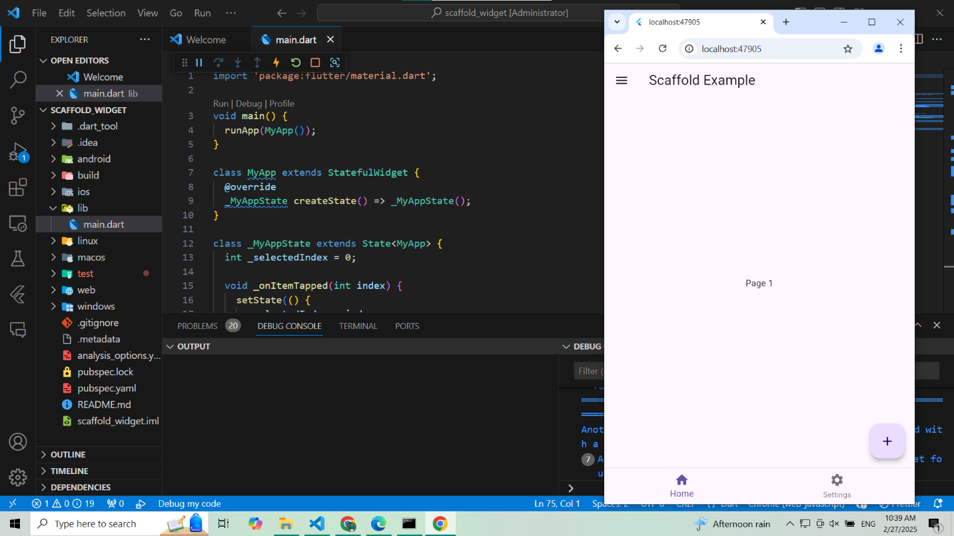

MaterialApp

**import 'package:flutter/material.dart';**

**void main() {**

**runApp(MyApp());**

**}**

**class MyApp extends StatelessWidget {**

**@override**

**Widget build(BuildContext context) {**

**return MaterialApp(**

**title: 'Flutter Demo',**

**theme: ThemeData(**

**primarySwatch: Colors.blue,**

**),**

**home: Scaffold(**

**appBar: AppBar(title: Text("MaterialApp Example")),**

**body: Center(child: Text("Welcome to MaterialApp")),**

**),**

**);**

**}**

**}**

BottomNavigationBar Widget

**import 'package:flutter/material.dart';**

**void main() {**

**runApp(MyApp());**

**}**

**class MyApp extends StatefulWidget {**

**@override**

**_MyAppState createState() => _MyAppState();**

**}**

**class _MyAppState extends State<MyApp> {**

**int _selectedIndex = 0;**

**static List<Widget> _widgetOptions = <Widget>[**

**Text('Home Screen'),**

**Text('Settings Screen'),**

**];**

**void _onItemTapped(int index) {**

**setState(() {**

**_selectedIndex = index;**

**});**

**}**

**@override**

**Widget build(BuildContext context) {**

**return MaterialApp(**

**home: Scaffold(**

**appBar: AppBar(title: Text("Bottom Navigation Example")),**

**body: Center(child: _widgetOptions.elementAt(_selectedIndex)),**

**bottomNavigationBar: BottomNavigationBar(**

**items: const <BottomNavigationBarItem>[**

**BottomNavigationBarItem(icon: Icon(Icons.home), label: 'Home'),**

**BottomNavigationBarItem(**

**icon: Icon(Icons.settings), label: 'Settings'),**

**],**

**currentIndex: _selectedIndex,**

**onTap: _onItemTapped,**

**),**

**),**

**);**

**}**

**}**

ClipRRect Widget

**import 'package:flutter/material.dart';**

**void main() {**

**runApp(MyApp());**

**}**

**class MyApp extends StatelessWidget {**

**@override**

**Widget build(BuildContext context) {**

**return MaterialApp(**

**home: Scaffold(**

**appBar: AppBar(**

**title: Text("ClipRRect Example"),**

**),**

**body: Center(**

**child: ClipRRect(**

**borderRadius: BorderRadius.circular(20),**

**child: Image.network('https://via.placeholder.com/150'),**

**),**

**),**

**),**

**);**

**}**

**}**

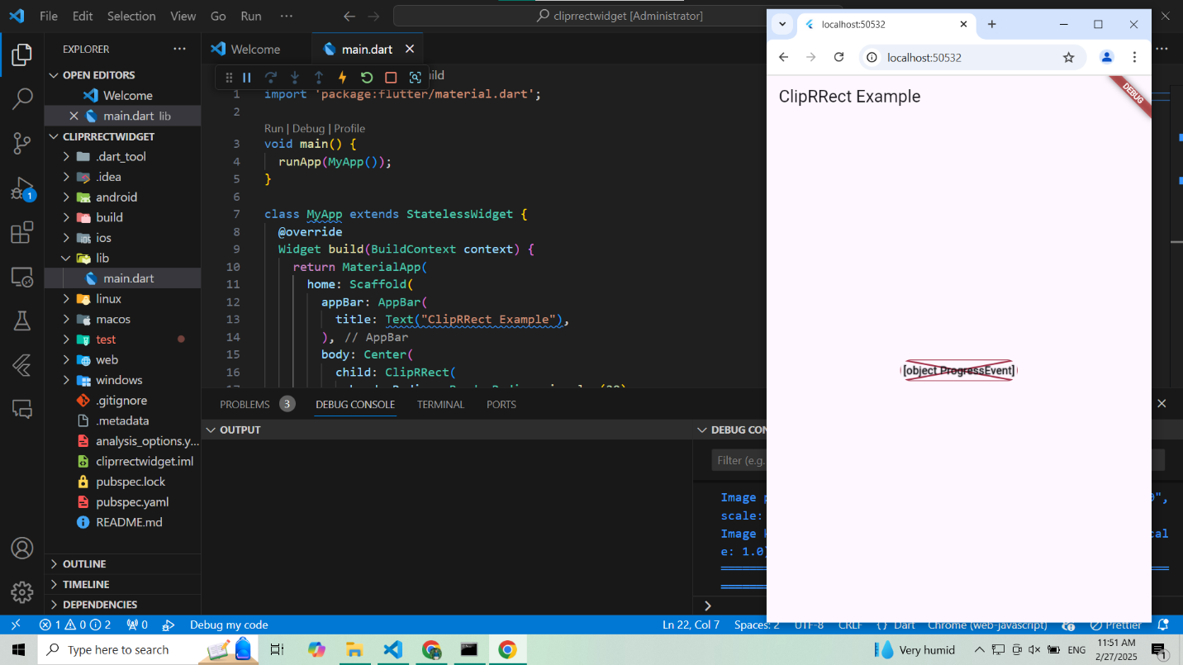

Drawer Widget

**import 'package:flutter/material.dart';**

**void main() {**

**runApp(MyApp());**

**}**

**class MyApp extends StatelessWidget {**

**@override**

**Widget build(BuildContext context) {**

**return MaterialApp(**

**home: Scaffold(**

**appBar: AppBar(**

**title: Text("Drawer Example"),**

**),**

**drawer: Drawer(**

**child: ListView(**

**children: [**

**DrawerHeader(**

**decoration: BoxDecoration(color: Colors.blue),**

**child: Text("Menu", style: TextStyle(color: Colors.white)),**

**),**

**ListTile(title: Text("Home"), onTap: () {}),**

**ListTile(title: Text("Settings"),onTap: () {}),**

**],**

**),**

**),**

**body: Center(child: Text("Drawer Example"),),**

**),**

**);**

**}**

**}**

Opacity Widget

**import 'package:flutter/material.dart';**

**void main(){**

**runApp(MyApp());**

**}**

**class MyApp extends StatelessWidget{**

**@override**

**Widget build(BuildContext context) {**

**return MaterialApp(**

**home: Scaffold(**

**body: Center(**

**child: Opacity(opacity: 0.5,**

**child: Text("Transparent Text"),**

**),**

**),**

**),**

**);**

**}**

**}**

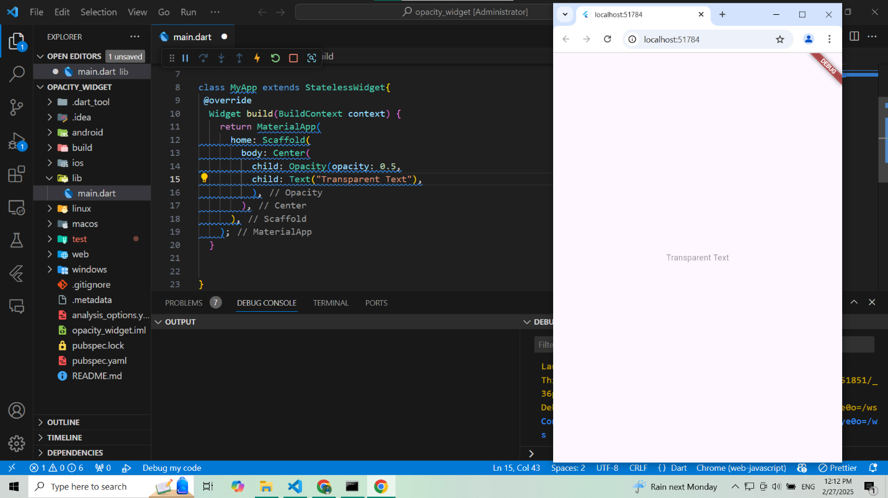

RotatedBox Widget

**import 'package:flutter/material.dart';**

**void main(){**

**runApp(MyApp());**

**}**

**class MyApp extends StatelessWidget{**

**@override**

**Widget build(BuildContext context) {**

**return MaterialApp(**

**home: Scaffold(**

**appBar: AppBar(title: Text("RotatedBox Example")),**

**body: Center(child: RotatedBox(quarterTurns: 1,**

**child: Text("Rotated Text"),),),**

**),**

**);**

**}**

**}**

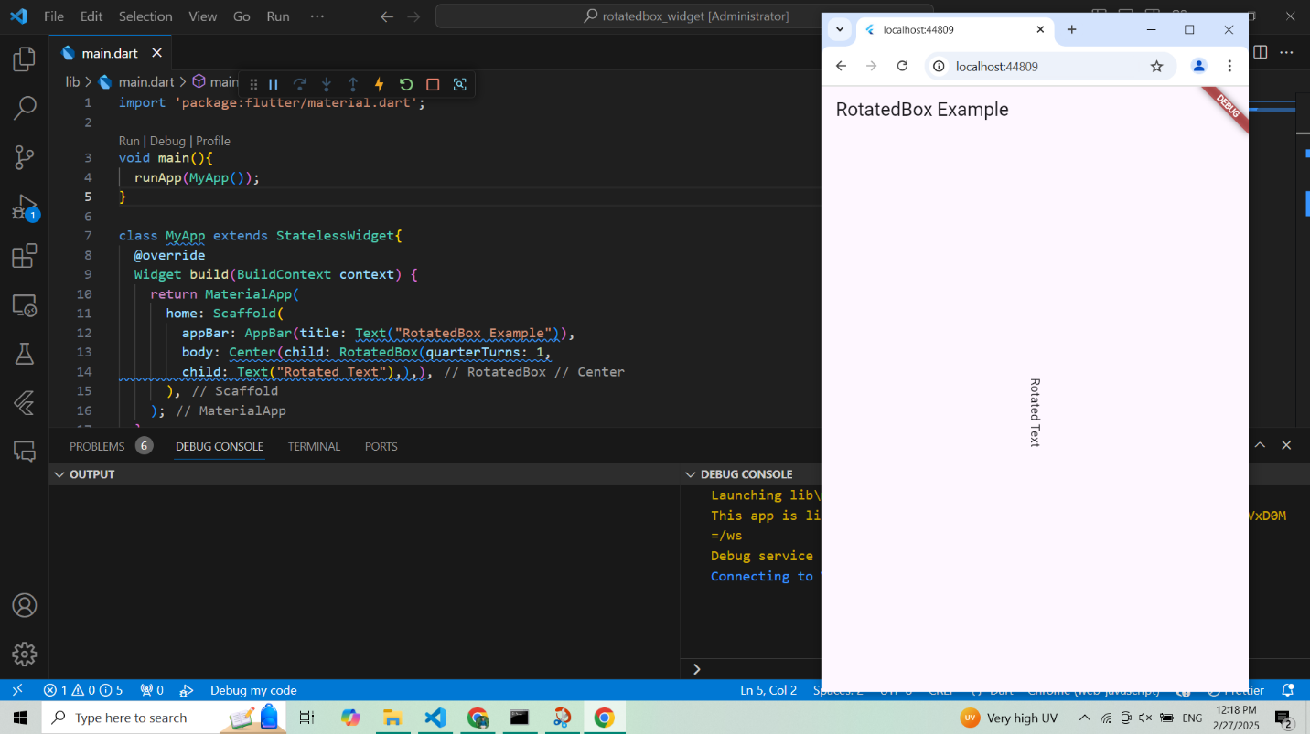

RichText Widget

**import 'package:flutter/material.dart';**

**void main() {**

**runApp(MyApp());**

**}**

**class MyApp extends StatelessWidget {**

**@override**

**Widget build(BuildContext context) {**

**return MaterialApp(**

**home: Scaffold(**

**appBar: AppBar(title: Text("Rich Text Example")),**

**body: Center(**

**child: RichText(**

**text: TextSpan(**

**style: TextStyle(fontSize: 24, color: Colors.black),**

**children: <TextSpan>[**

**TextSpan(**

**text: "Bold Text\n",**

**style: TextStyle(fontWeight: FontWeight.bold)),**

**TextSpan(text: "Normal Text"),**

**])),**

**),**

**),**

**);**

**}**

**}**

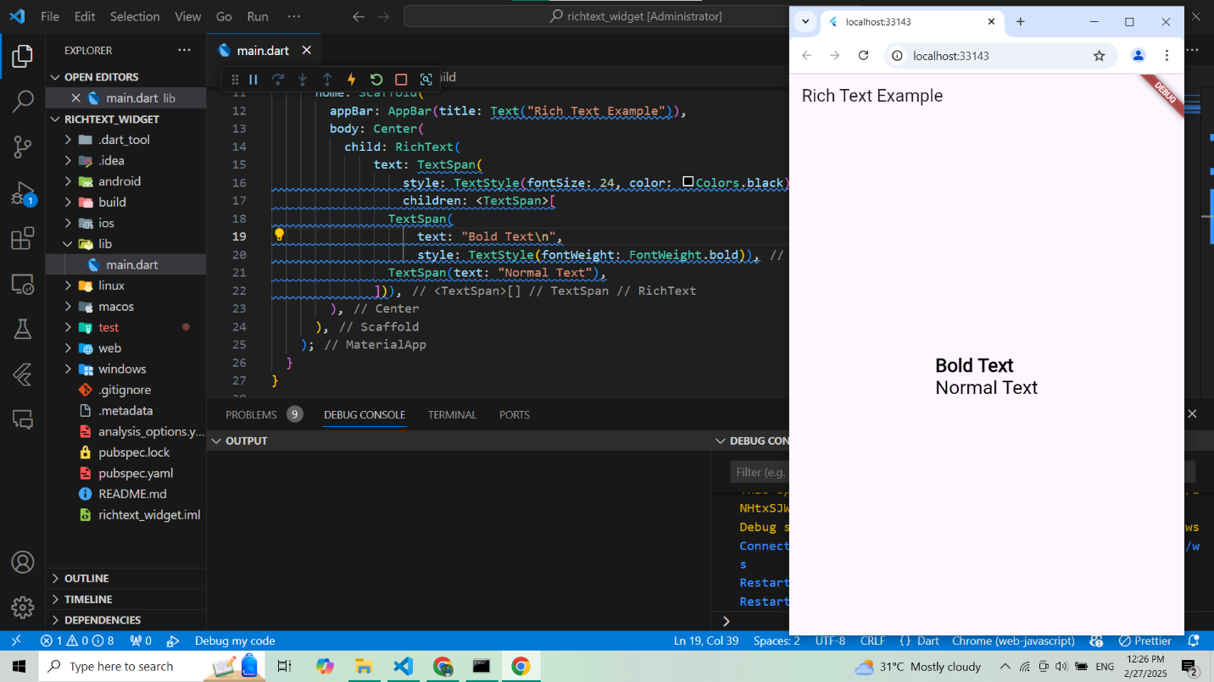

OctoImage Widget

**import 'package:flutter/material.dart';**

**import 'package:octo_image/octo_image.dart';**

**void main() {**

**runApp(MyApp());**

**}**

**class MyApp extends StatelessWidget {**

**@override**

**Widget build(BuildContext context) {**

**return MaterialApp(**

**home: Scaffold(**

**appBar: AppBar(title: Text("OctoImage Example")),**

**body: Center(**

**child: OctoImage(**

**image: NetworkImage('https://via.placeholder.com/150'),**

**placeholderBuilder: (context) => Image.asset('assets/placeholder.png'),**

**errorBuilder: OctoError.icon(color: Colors.red),**

**)**

**),**

**),**

**);**

**}**

**}**

AppBar Widget

**import 'package:flutter/material.dart';**

**void main(){**

**runApp(MyApp());**

**}**

**class MyApp extends StatelessWidget {**

**@override**

**Widget build(BuildContext context) {**

**return MaterialApp(**

**home: Scaffold(**

**appBar: AppBar(**

**title: Text("AppBar Example"),**

**actions: [**

**IconButton(icon:Icon(Icons.search),onPressed: (){},)**

**],**

**),**

**body: Center(child: Text("AppBar Example"),),**

**),**

**);**

**}**

**}**

